First-Time
LEADER
Tool 7.1
Communication Planning

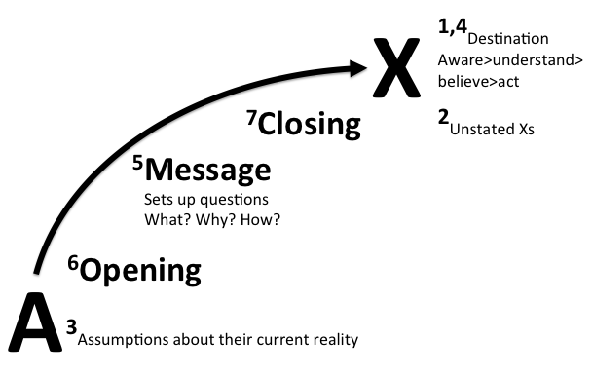

1. Identify your destination.
What is the desired reaction, feeling, and behavior you want from you audience/constituents?

What specifically do you want, not want them to understand, believe, say, and do?

2. Be explicit about unstated Xs.
What do you want listener to think and feel about you?

3. Assess current reality.
What does your audience/constituency currently understand, believe, say? Why?

Develop a risk management plan including: potential obstacles, negative rumors, sabotage, legal requirements, unintended consequences, and scenarios.

4. Reevaluate destination in light of assumptions about audience.

5. Bridge the gap.
What do people need to be aware of, understand, believe, and feel to move from current reality to your destination?

6. Develop core ideas and key communication points (maximum 5 core ideas).

7. Package the message.
How should core ideas be packaged for optimum effectiveness?

What kind of supporting data do you need?

What is your key opening idea?

What is your key closing idea?

8. Deliver the message.
What are the best vehicles to reach your audience or constituents?

What is the optimum combination?

What is the best timing to release the message?

Who and what influences whom - amplifiers?

How do you best plant the follow-up seeds?

1. Much of this is based on work by Sandy Linver and her company Speakeasy, also laid out in her book Speak and get Results, Simon and Schuster 1994

